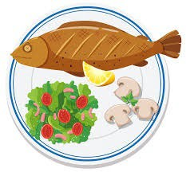
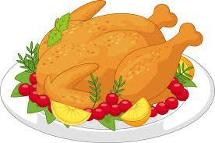
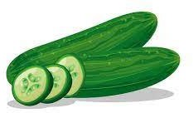

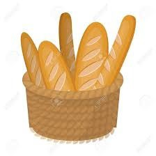
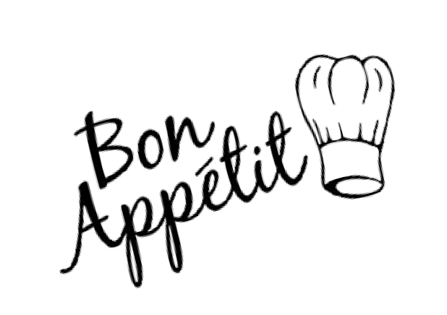


MENU 1

Monday
Tuesday
Thursday
Friday

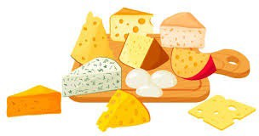
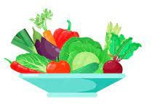

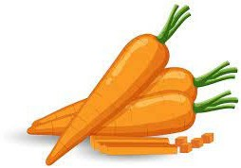


*Salad Items: Tomatoes, Plain cucumber, Plain beetroot, Herb leaf salad

Starters
Salads*

Mains Breaded Fish GF Traditional Cornish
French Fries Baked Beans Garden Peas Bread

Desserts**
Ice Cream Fresh Cut Fruit
Starters
Salads*

Mains
Greek Style Meat Pasta Vegetable Pasta Cabbage - Cauliflower Garlic Bread + Bread
Desserts** Pudding Custard
Cheese

Starters
Salads*

Mains
Roast Sweet chilli chicken Creamy Cauliflower Baked Long Grain Rice Sweetcorn - Courgette Gravy
Bread

Desserts** Biscuit Yoghurt

Starters
Salads*

Mains
Southern Chicken Goujon Herby Seasoned Potato Ketchup & Mayonnaise Creamy Ravioli
Green Beans - Carrot Bread

Desserts**
Yoghurt Fresh Cut Fruit
Pineapple & Oranges

sweetcorn, vinaigrette, fresh croutons, sunflower seeds & olive oil with lemon juice and black pepper
**Dessert Options: Fresh Fruit or Fruit Salad will be served every day

